Farlam parish council
Important Notice for your children’s safety

Swings in Hallbankgate Play Area
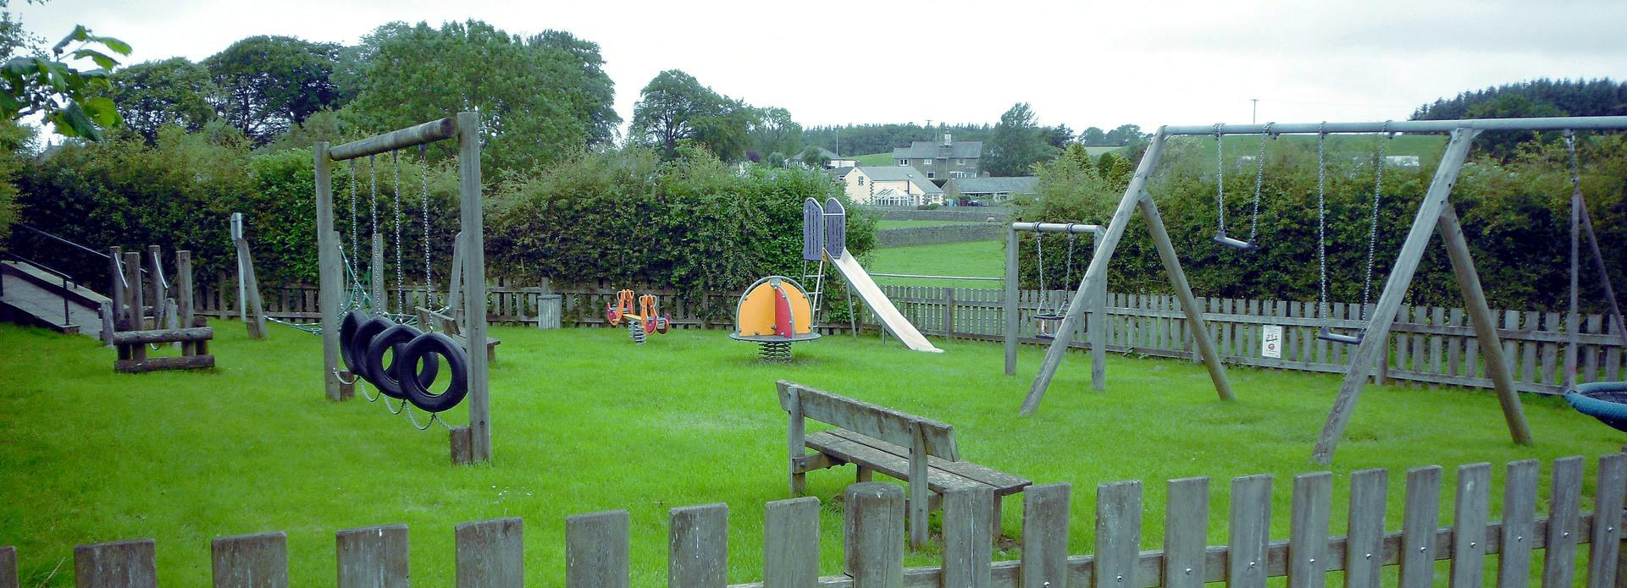
Please note that the swings and basket swing in the play area will be out of action until further notice.

Thank you.
TAble of
Contents
Emphasis Heading 1 1
Heading 2 1
Heading 2 2

Emphasis
Heading 1
To get started right away, just tap any placeholder text (such as this) and start typing.

Heading 2
View and edit this document in Word on your computer, tablet or phone.
You can edit text; easily insert content such as pictures, shapes or tables; and seamlessly save the document to the cloud from Word on your Windows, Mac, Android or iOS device.
“Quote”
Want to insert a picture from your files or add a shape, text box or table? Go for it! On the Insert tab of the ribbon, just tap the option you need.
Find even more easy-to-use tools on the Insert tab, such as to add a hyperlink or insert a comment.

Heading 2
- Use styles to easily format your Word documents in no time. For example, this text uses the List Bullet style.
- On the Home tab of the ribbon, check out Styles to apply the formatting you want with just a tap.
 | Column Heading | Column Heading
Row Heading | Text | 123.45
Row Heading | Text | 123.45

